**WITH NOISE AND WITHOUT FILTER**

**Image set:**

|  |
| --- |
| **Image 1:-0.1 % Noise** |

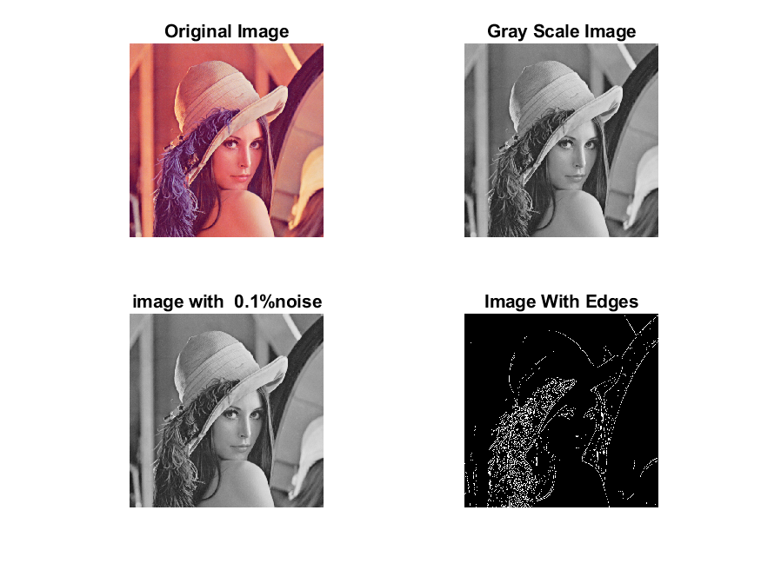

**Image 2:-10 % Noise**

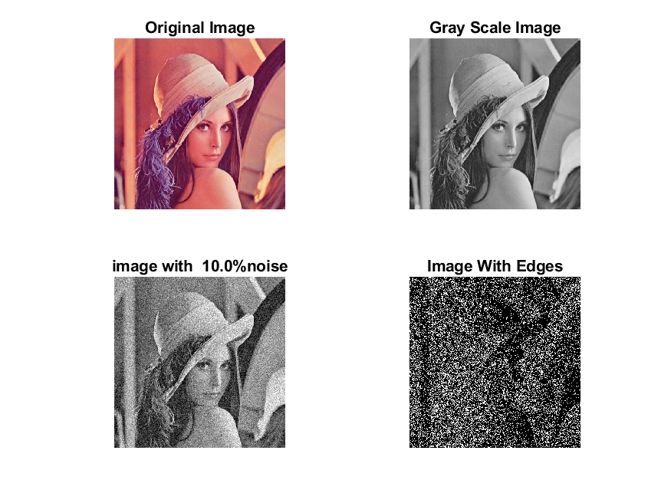

**Image 3:-20 % Noise**

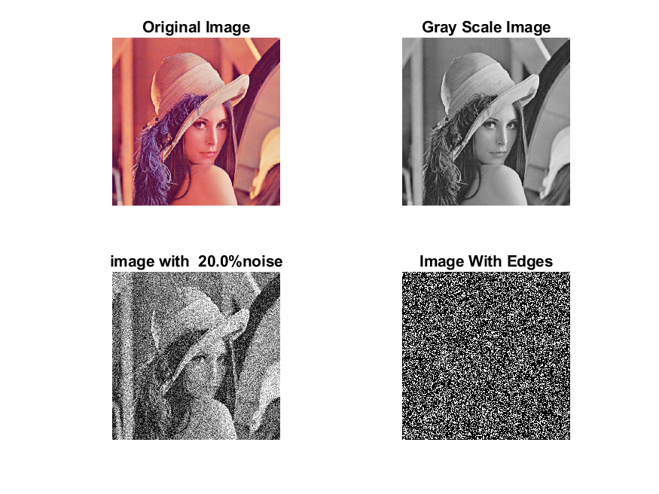

**Image 4:-30 % Noise**

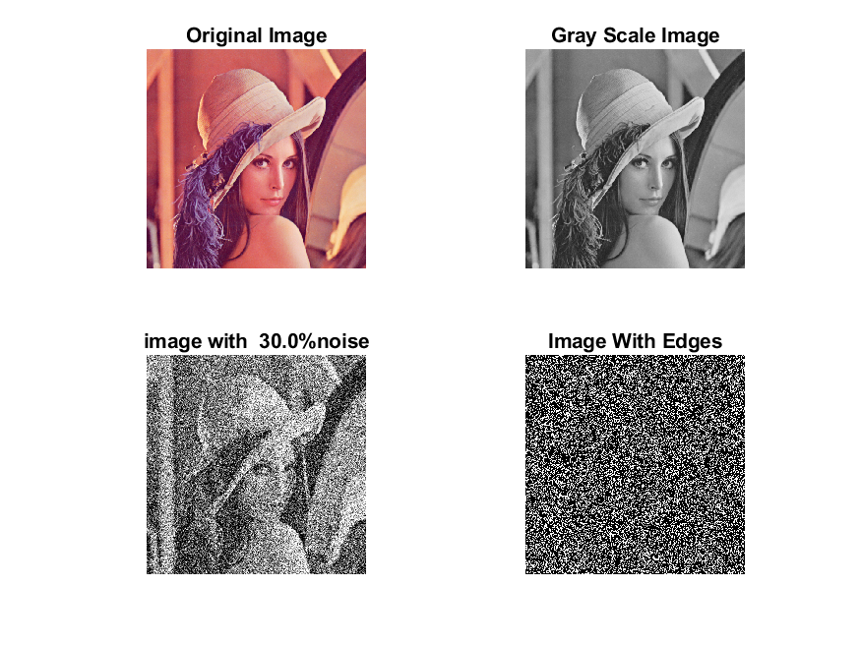

|  |
| --- |
| **Image 5:-40 % Noise** |

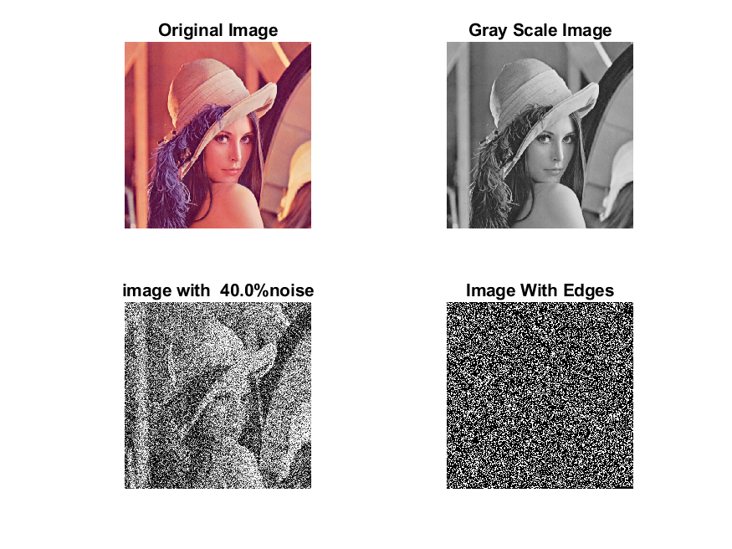

**Image 6:-50 % Noise**

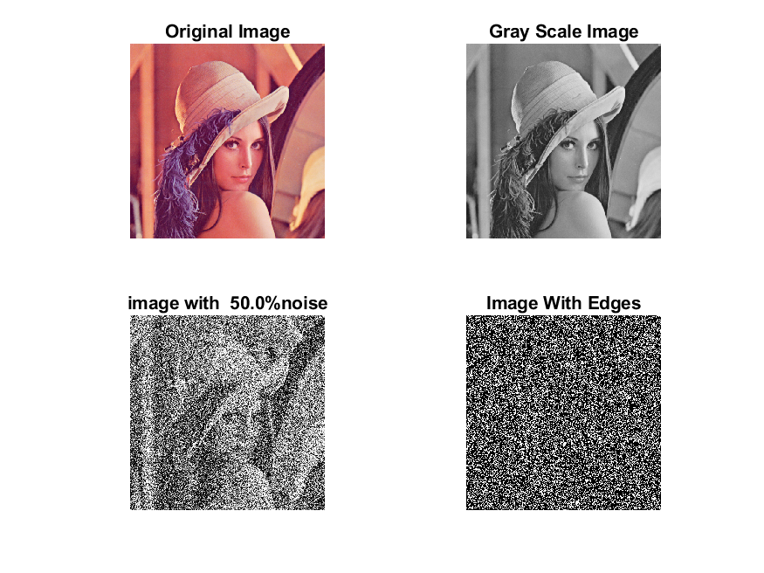

**Image 7:-60 % Noise**

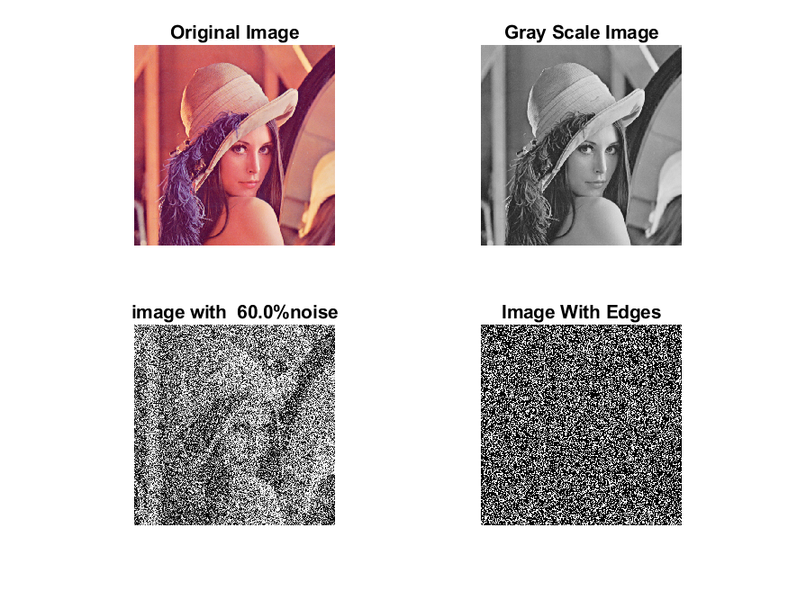

**Image 8:-70 % Noise**

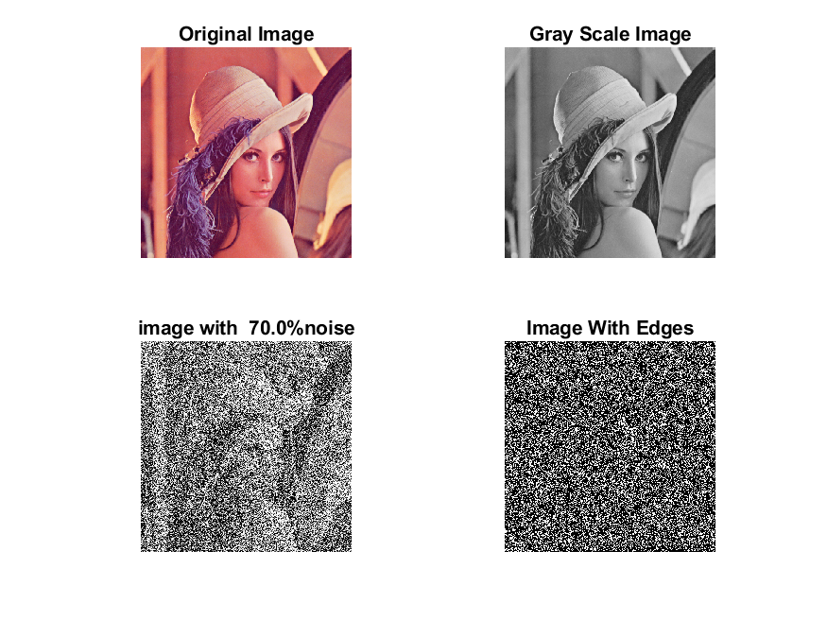

**Image 9:-80 % Noise**

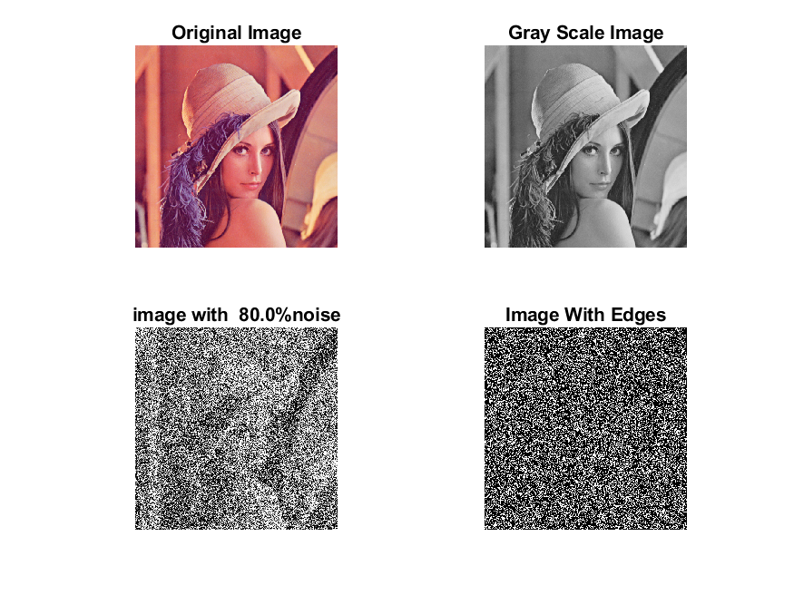

**DATA FILES**

**Image 1:-Noise0.1**

Original image ideal values:

IM1 image entropy:3.049803e-01

IM1 image mean:0.054443

Ground truth image entropy:0.633825

Ground truth image mean:0.159798

entropy between imt and im1 :0.594004

MSE between imt and im1 :0.182167

Average Difference between imt and im1 :0.105354

Maximum Difference between imt and im1 :1.000000

True Positive values:4204.000000

False Positive values: 10068.000000

True Negative values:210186.000000

False Negative values:37686.000000

Accuracy value: 0.817833

F Measure values:0.149710

Peak Signal-to Noise Ration value: 7.395302

Signal-to Noise Ration value: -4.676255

percentage of pixels that were correctly detected (Pco): 0.100358

The percentage of pixels that were not detected (Pnd):0.899642

the percentage of false alarm: (Pfa):0.240344

Euclidean Distance Value :9.128176

**Image 2:-Noise10**

Original image ideal values:

IM1 image entropy:8.257348e-01

IM1 image mean:0.259331

Ground truth image entropy:0.633825

Ground truth image mean:0.159798

entropy between imt and im1 :0.507511

MSE between imt and im1 :0.324600

Average Difference between imt and im1 :-0.099533

Maximum Difference between imt and im1 :1.000000

True Positive values:12390.000000

False Positive values: 55592.000000

True Negative values:164662.000000

False Negative values:29500.000000

Accuracy value: 0.675400

F Measure values:0.225535

Peak Signal-to Noise Ration value: 4.886512

Signal-to Noise Ration value: 2.102836

percentage of pixels that were correctly detected (Pco): 0.182254

The percentage of pixels that were not detected (Pnd):0.433938

the percentage of false alarm: (Pfa):0.817746

Euclidean Distance Value :17.270977

**Image 3:-Noise20**

Original image ideal values:

IM1 image entropy:9.085259e-01

IM1 image mean:0.323856

Ground truth image entropy:0.633825

Ground truth image mean:0.159798

entropy between imt and im1 :0.492102

MSE between imt and im1 :0.378910

Average Difference between imt and im1 :-0.164059

Maximum Difference between imt and im1 :1.000000

True Positive values:13729.000000

False Positive values: 71168.000000

True Negative values:149086.000000

False Negative values:28161.000000

Accuracy value: 0.621090

F Measure values:0.216568

Peak Signal-to Noise Ration value: 4.214639

Signal-to Noise Ration value: 3.067820

percentage of pixels that were correctly detected (Pco): 0.161714

The percentage of pixels that were not detected (Pnd):0.331708

the percentage of false alarm: (Pfa):0.838286

Euclidean Distance Value :15.222291

**Image 4:-Noise30**

Original image ideal values:

IM1 image entropy:9.159616e-01

IM1 image mean:0.331017

Ground truth image entropy:0.633825

Ground truth image mean:0.159798

entropy between imt and im1 :0.490562

MSE between imt and im1 :0.385063

Average Difference between imt and im1 :-0.171219

Maximum Difference between imt and im1 :1.000000

True Positive values:13861.000000

False Positive values: 72913.000000

True Negative values:147341.000000

False Negative values:28029.000000

Accuracy value: 0.614937

F Measure values:0.215460

Peak Signal-to Noise Ration value: 4.144680

Signal-to Noise Ration value: 3.162793

percentage of pixels that were correctly detected (Pco): 0.159737

The percentage of pixels that were not detected (Pnd):0.323012

the percentage of false alarm: (Pfa):0.840263

Euclidean Distance Value :15.025274

**Image 5:-Noise40**

Original image ideal values:

IM1 image entropy:9.193363e-01

IM1 image mean:0.334377

Ground truth image entropy:0.633825

Ground truth image mean:0.159798

entropy between imt and im1 :0.489158

MSE between imt and im1 :0.387508

Average Difference between imt and im1 :-0.174580

Maximum Difference between imt and im1 :1.000000

True Positive values:13981.000000

False Positive values: 73674.000000

True Negative values:146580.000000

False Negative values:27909.000000

Accuracy value: 0.612492

F Measure values:0.215848

Peak Signal-to Noise Ration value: 4.117189

Signal-to Noise Ration value: 3.206663

percentage of pixels that were correctly detected (Pco): 0.159500

The percentage of pixels that were not detected (Pnd):0.318396

the percentage of false alarm: (Pfa):0.840500

Euclidean Distance Value :15.001623

**Image 6:-Noise50**

Original image ideal values:

IM1 image entropy:9.220138e-01

IM1 image mean:0.337097

Ground truth image entropy:0.633825

Ground truth image mean:0.159798

entropy between imt and im1 :0.486930

MSE between imt and im1 :0.388779

Average Difference between imt and im1 :-0.177299

Maximum Difference between imt and im1 :1.000000

True Positive values:14171.000000

False Positive values: 74197.000000

True Negative values:146057.000000

False Negative values:27719.000000

Accuracy value: 0.611221

F Measure values:0.217584

Peak Signal-to Noise Ration value: 4.102976

Signal-to Noise Ration value: 3.241847

percentage of pixels that were correctly detected (Pco): 0.160363

The percentage of pixels that were not detected (Pnd):0.313677

the percentage of false alarm: (Pfa):0.839637

Euclidean Distance Value :15.087447

**Image 7:-Noise60**

Original image ideal values:

IM1 image entropy:9.261812e-01

IM1 image mean:0.341431

Ground truth image entropy:0.633825

Ground truth image mean:0.159798

entropy between imt and im1 :0.485648

MSE between imt and im1 :0.392281

Average Difference between imt and im1 :-0.181633

Maximum Difference between imt and im1 :1.000000

True Positive values:14280.000000

False Positive values: 75224.000000

True Negative values:145030.000000

False Negative values:27610.000000

Accuracy value: 0.607719

F Measure values:0.217362

Peak Signal-to Noise Ration value: 4.064032

Signal-to Noise Ration value: 3.297321

percentage of pixels that were correctly detected (Pco): 0.159546

The percentage of pixels that were not detected (Pnd):0.308478

the percentage of false alarm: (Pfa):0.840454

Euclidean Distance Value :15.005937

**Image 8:-Noise70**

Original image ideal values:

IM1 image entropy:9.278272e-01

IM1 image mean:0.343178

Ground truth image entropy:0.633825

Ground truth image mean:0.159798

entropy between imt and im1 :0.484304

MSE between imt and im1 :0.393158

Average Difference between imt and im1 :-0.183380

Maximum Difference between imt and im1 :1.000000

True Positive values:14394.000000

False Positive values: 75568.000000

True Negative values:144686.000000

False Negative values:27496.000000

Accuracy value: 0.606842

F Measure values:0.218336

Peak Signal-to Noise Ration value: 4.054329

Signal-to Noise Ration value: 3.319487

percentage of pixels that were correctly detected (Pco): 0.160001

The percentage of pixels that were not detected (Pnd):0.305640

the percentage of false alarm: (Pfa):0.839999

Euclidean Distance Value :15.051166

**Image 9:-Noise80**

Original image ideal values:

IM1 image entropy:9.307360e-01

IM1 image mean:0.346317

Ground truth image entropy:0.633825

Ground truth image mean:0.159798

entropy between imt and im1 :0.484658

MSE between imt and im1 :0.396526

Average Difference between imt and im1 :-0.186520

Maximum Difference between imt and im1 :1.000000

True Positive values:14364.000000

False Positive values: 76421.000000

True Negative values:143833.000000

False Negative values:27526.000000

Accuracy value: 0.603474

F Measure values:0.216529

Peak Signal-to Noise Ration value: 4.017280

Signal-to Noise Ration value: 3.359037

percentage of pixels that were correctly detected (Pco): 0.158220

The percentage of pixels that were not detected (Pnd):0.303200

the percentage of false alarm: (Pfa):0.841780

Euclidean Distance Value :14.873816